**Creating a Custom AMI and Deploying an Auto Scaling Group behind an Application Load Balancer**

**Hands-on Lab**

We will undergo the process of standing up a working Web Server on Amazon EC2, creating a custom AMI using the instance, and then deploying an Auto Scaling Group using the newly created AMI.

**Objectives**

* Create AMI of Amazon EC2 Instance
* Create Launch Template
* Create Auto Scaling Group and Scaling Policy
* Test Scaling

**Architecture**

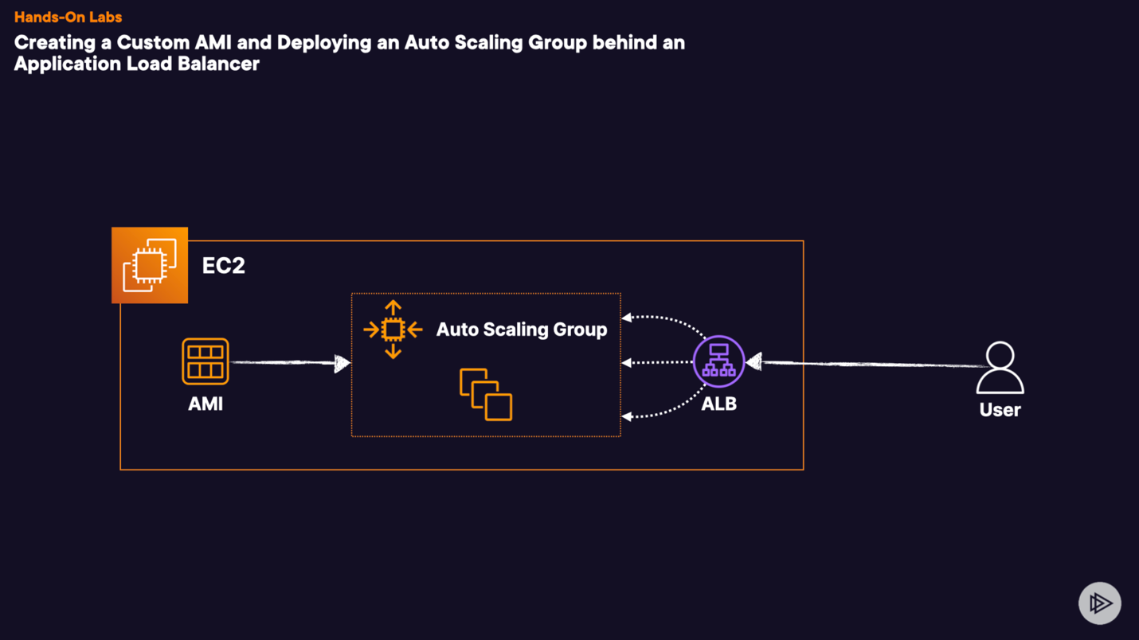

We are going to work over an EC2 with Apache and a basic HTML page, this page is saved in /var/www/html/index.html

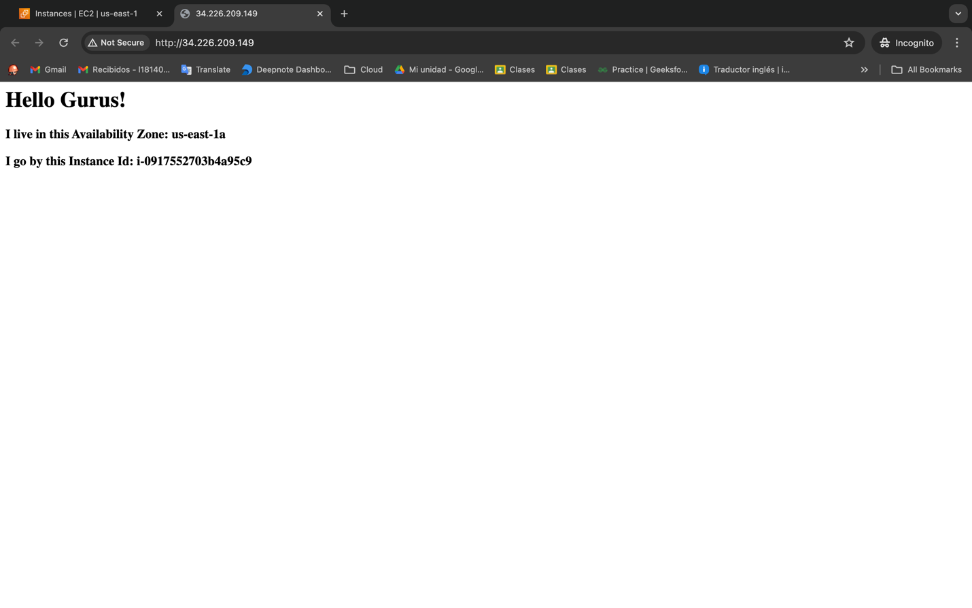

The instance has Apache installed, is attach to VPC, NACL, Security Group with the port 80 open, the instance type is t3.medium

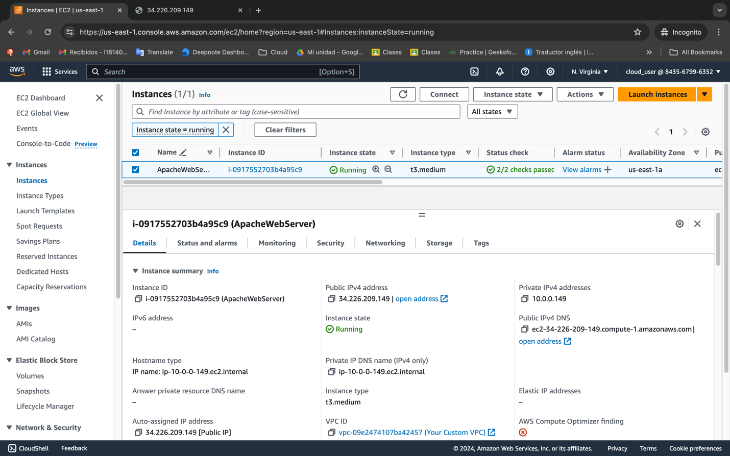

The first thing we need to do is create an image from this EC2 instance, for this we select the instance and we go to Actions > Image and templates > Create image

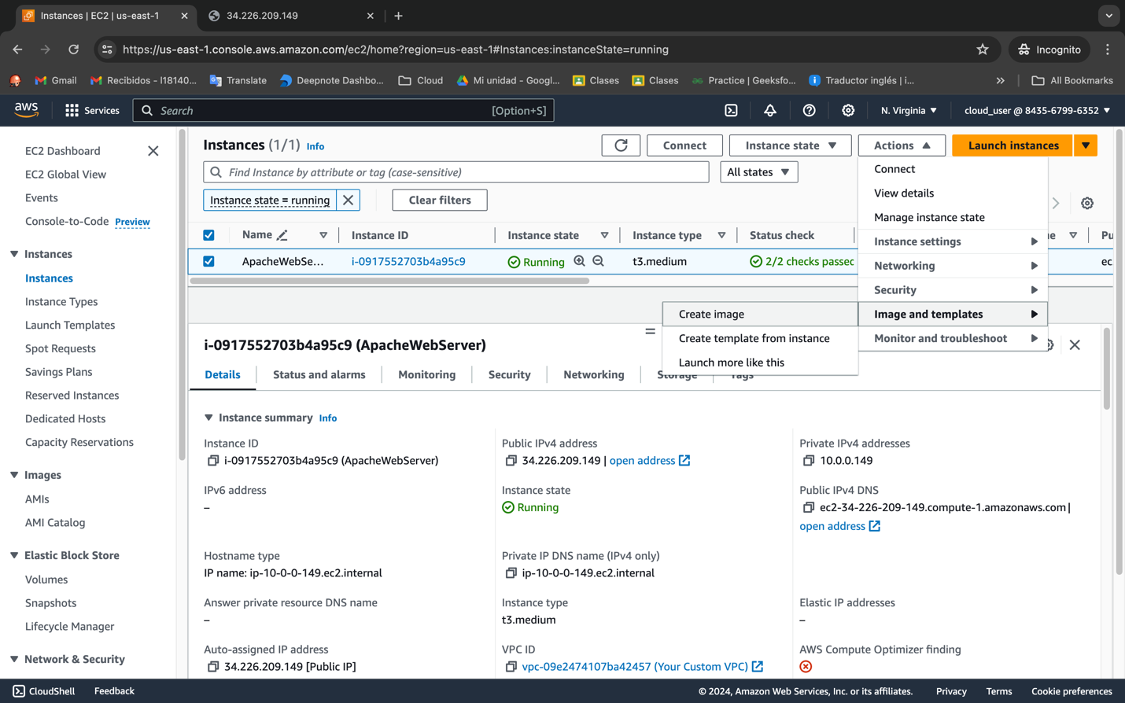

We called the image WebServer, we left the default Settings in instance volumes and tags.

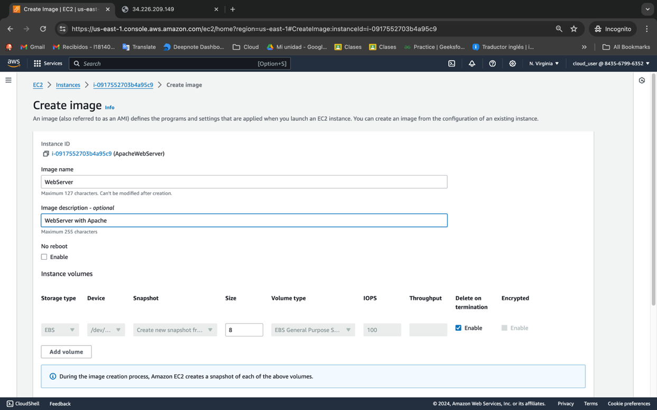

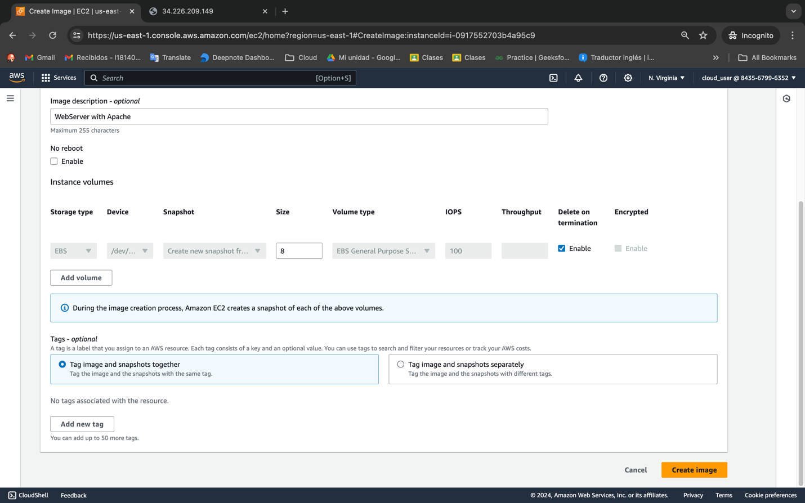

We can review the information from Images > AMIs

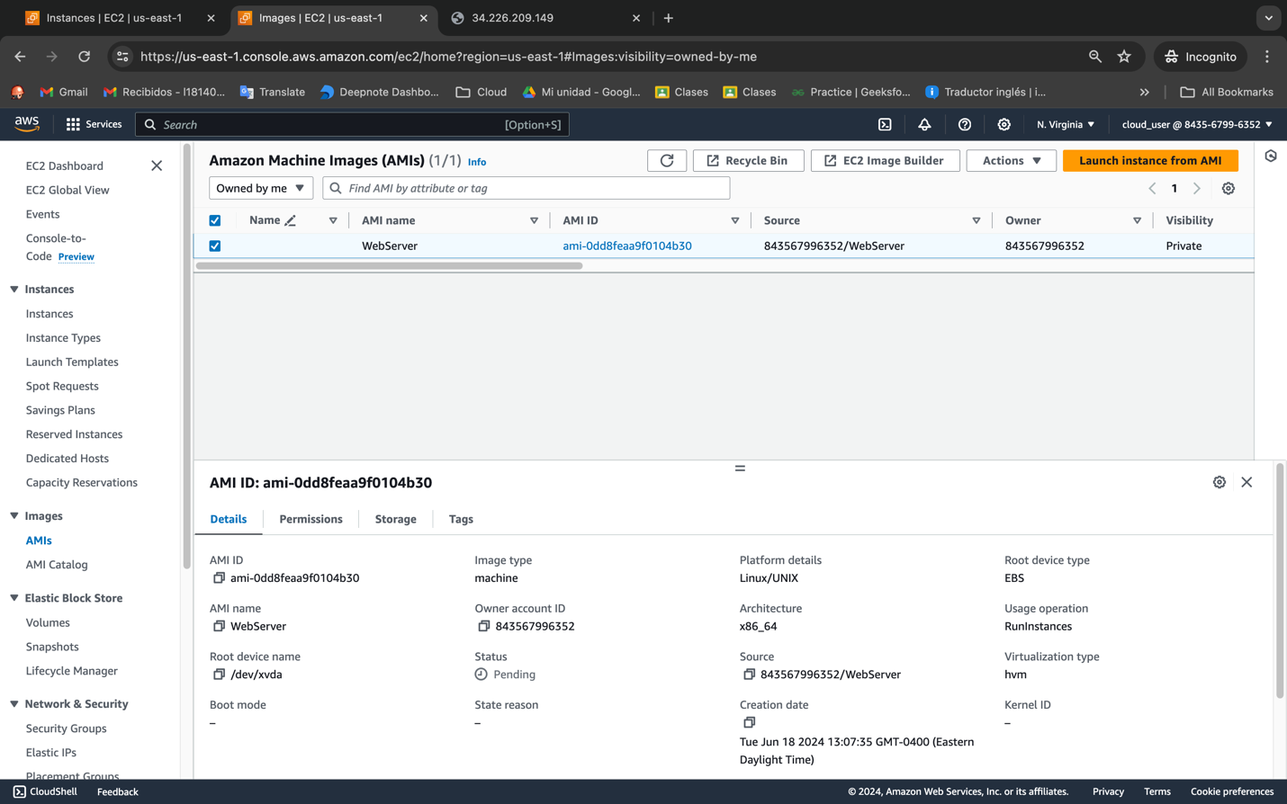

Now we need to create a launch template

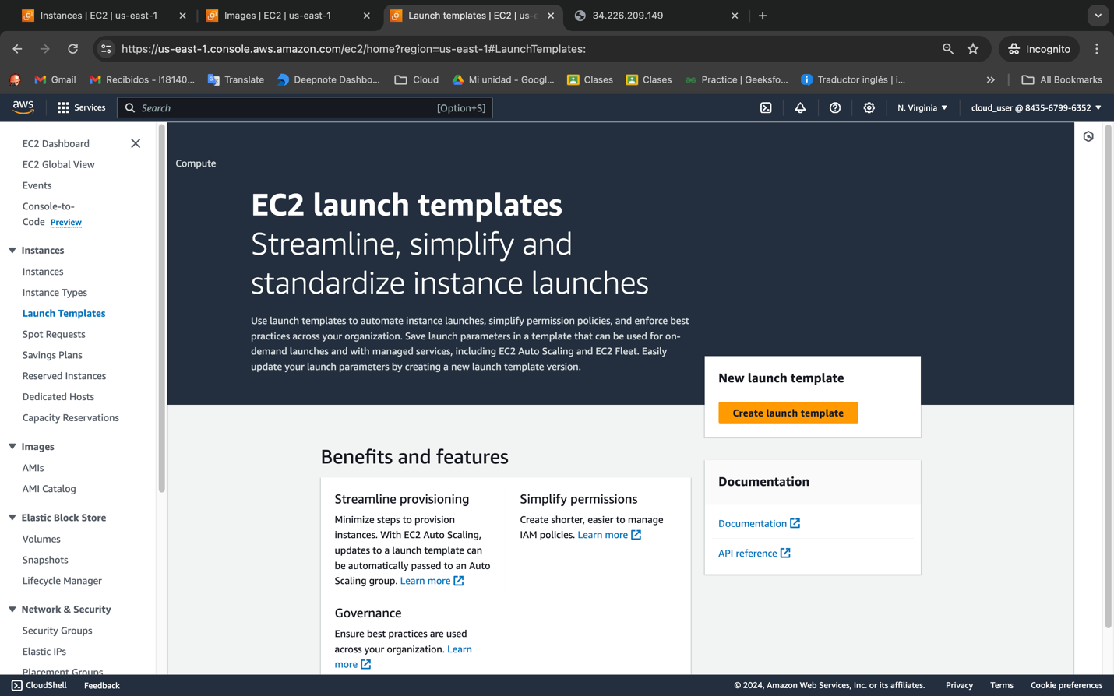

We will call the launch template WebServerLT, you can add a description is optional.

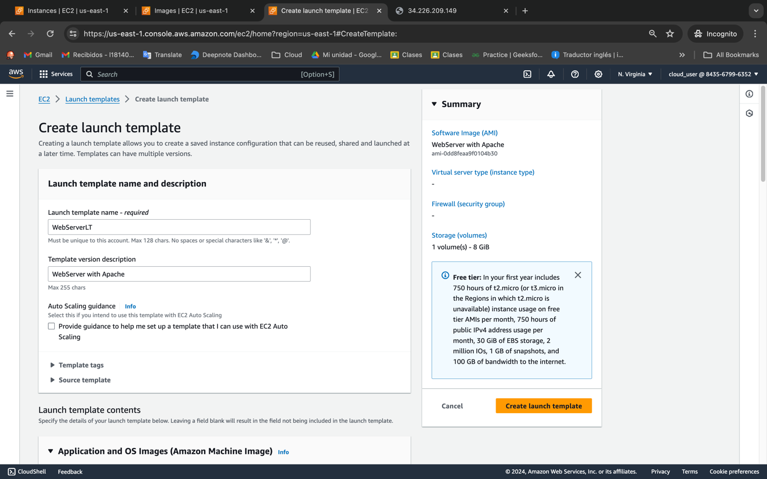

In the step of Application and OS we are going to use the AMIs we recently create it.

The type of EC2 we will use is t3.micro.

*Note: If you need to provide flexibility with the type of your EC2 in your auto scaling group don’t select instance type instead.*

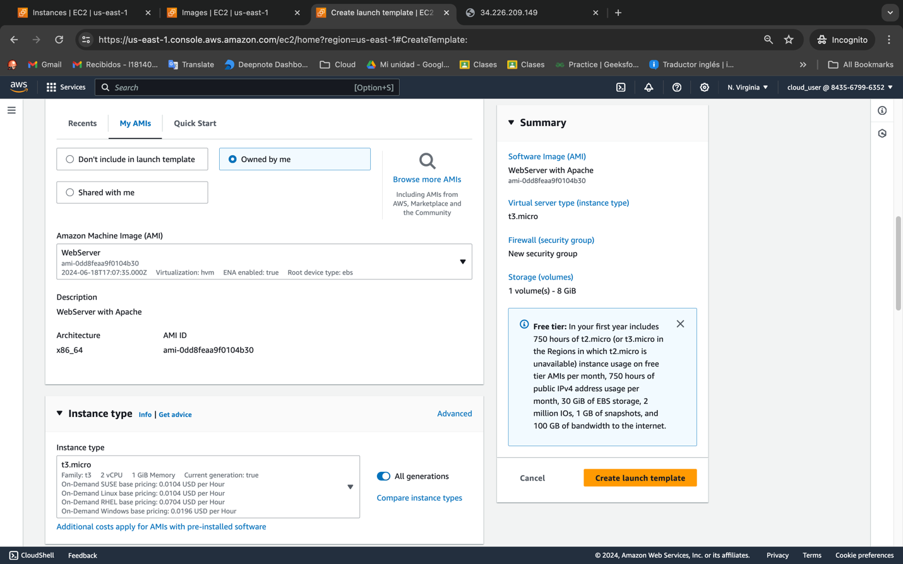

Now we are going to create a security group to allow traffic from our VPC to our EC2 allowing HTTP traffic in port 80.

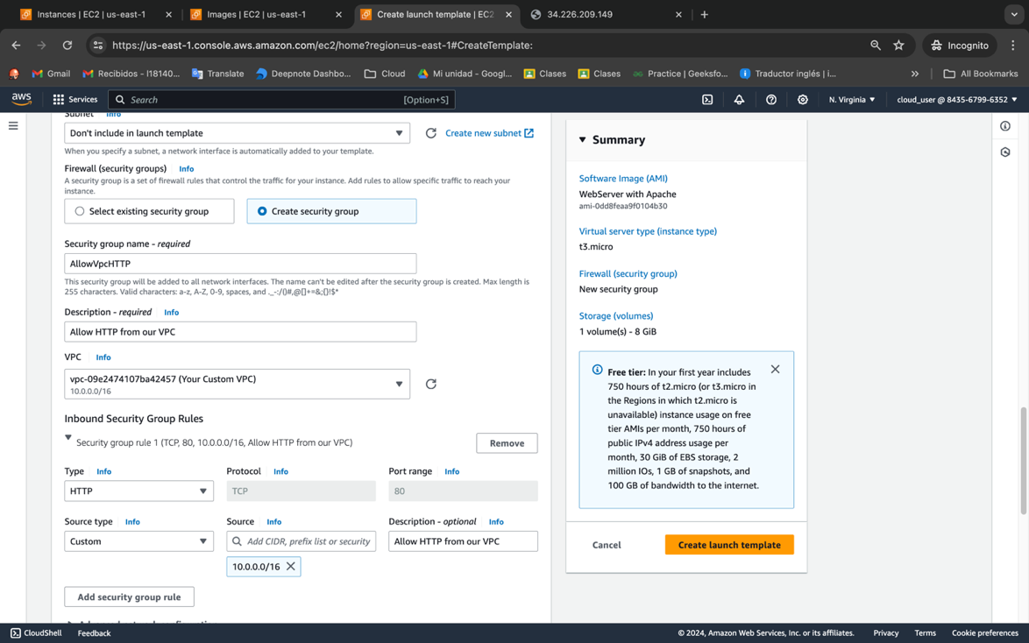

Now we add our user data and our instance profile. The user data is below the images and what it does is update packages, install httpd to deploy webs and configure the service also create a basic HTML web page and stored in /var/www/html/index.html, also we are going to install a library to stress our CPU and simulate peaks of traffic to see the function of the auto scaling group.

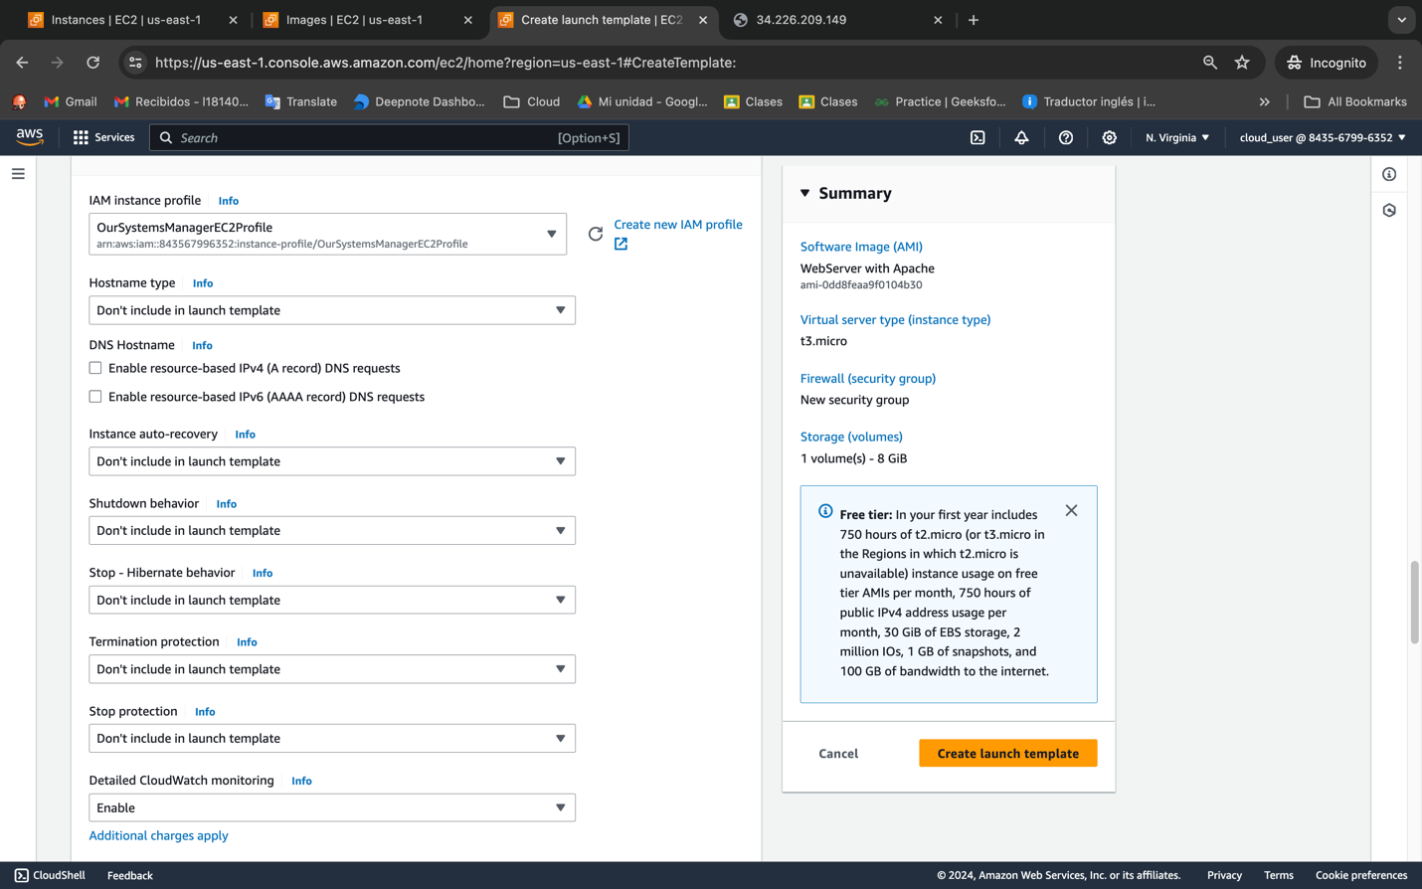

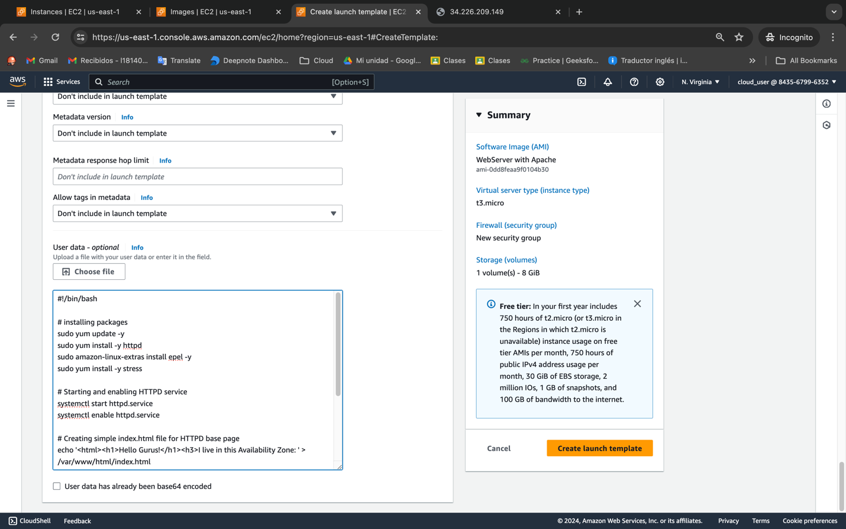

You should install all original packages, run all those original scripts in that original EC2. But for us this index.html is not necessarily dynamic. So because of this, this was ran in the original ec2 instance, but what it does is hard code values into that webpage

We want it to be dynamic as far as deploying on each ec2 instance differently

#!/bin/bash

# installing packages

sudo yum update -y

sudo yum install -y httpd

sudo amazon-linux-extras install epel -y

sudo yum install -y stress

# Starting and enabling HTTPD service

systemctl start httpd.service

systemctl enable httpd.service

# Creating simple index.html file for HTTPD base page

echo '<html><h1>Hello Gurus!</h1><h3>I live in this Availability Zone: ' > /var/www/html/index.html

curl http://169.254.169.254/latest/meta-data/placement/availability-zone >> /var/www/html/index.html

echo '</h3> <h3>I go by this Instance Id: ' >> /var/www/html/index.html

curl http://169.254.169.254/latest/meta-data/instance-id >> /var/www/html/index.html

echo '</h3></html> ' >> /var/www/html/index.html

# Restarting HTTPD service to enforce new index.html just to be safe.

systemctl restart httpd.service

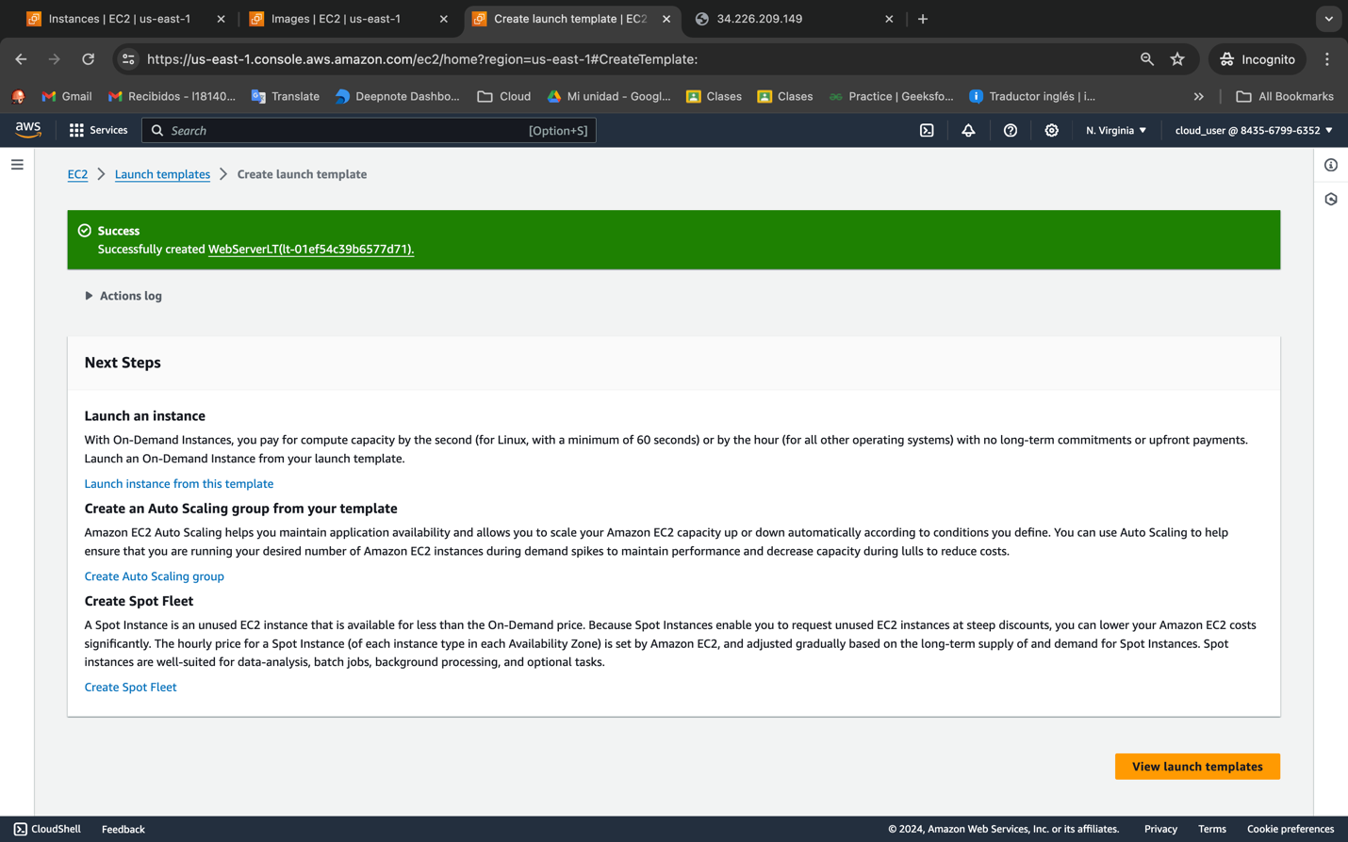

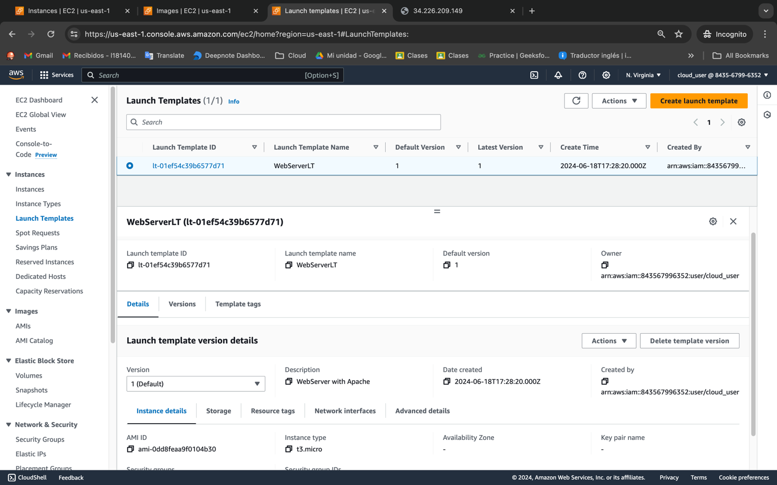

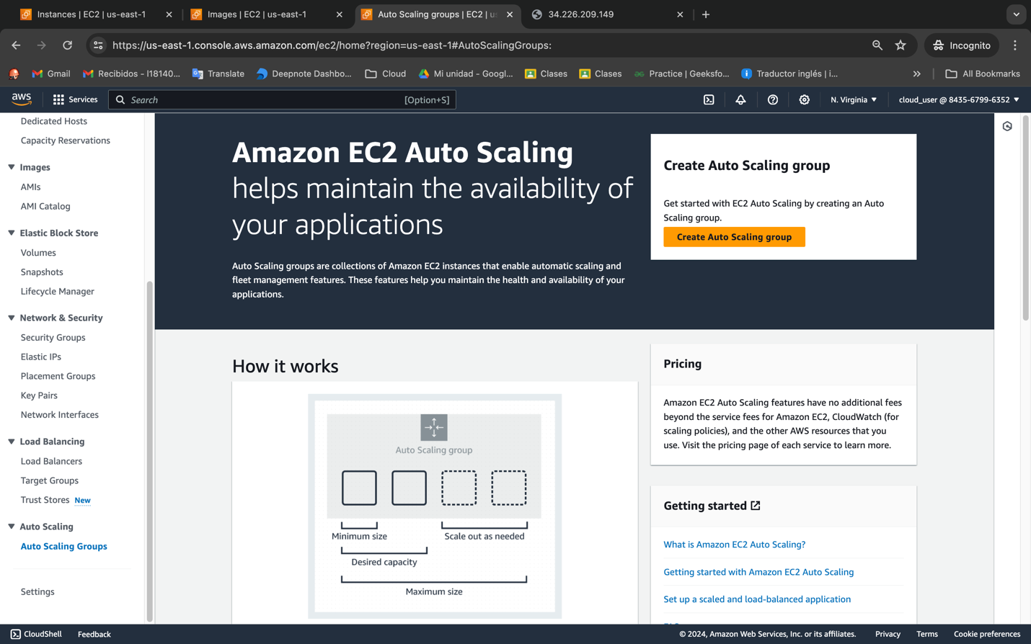

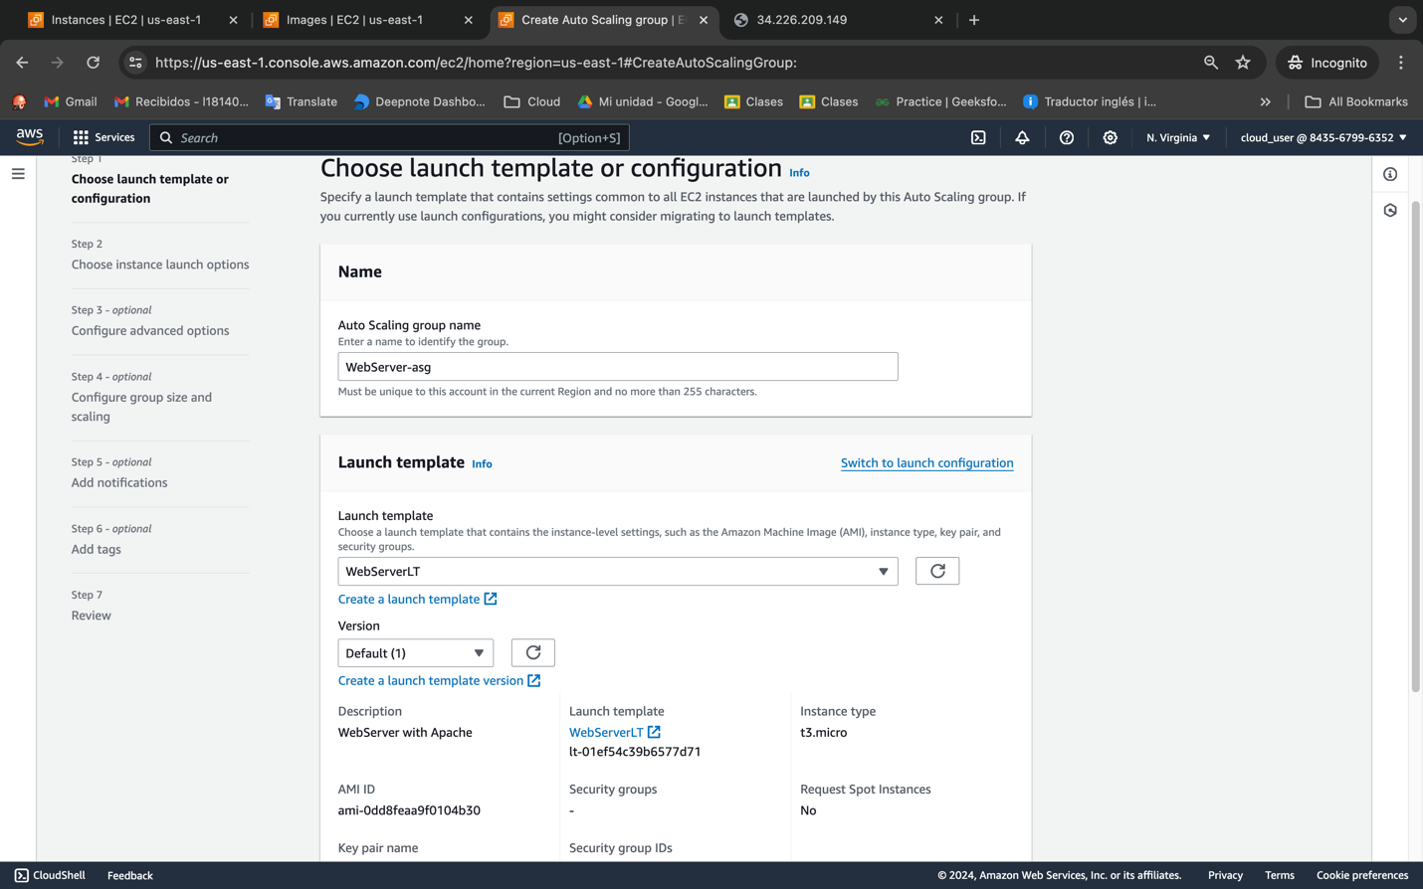

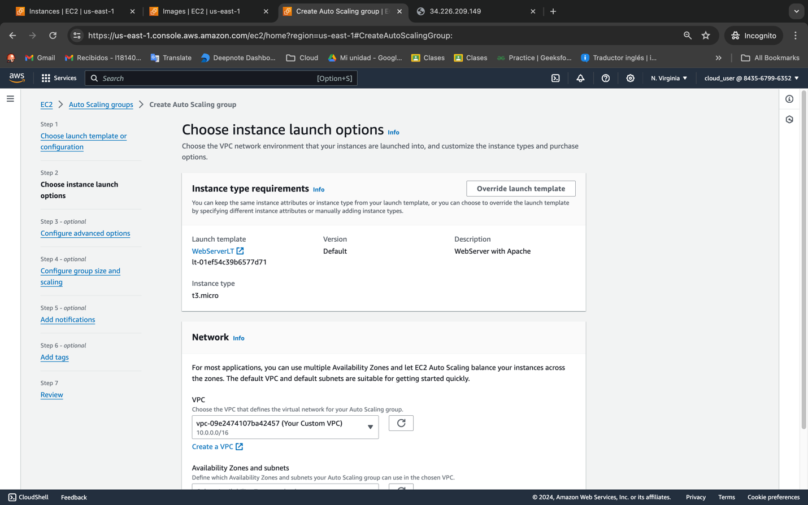

Its gonna be private servers

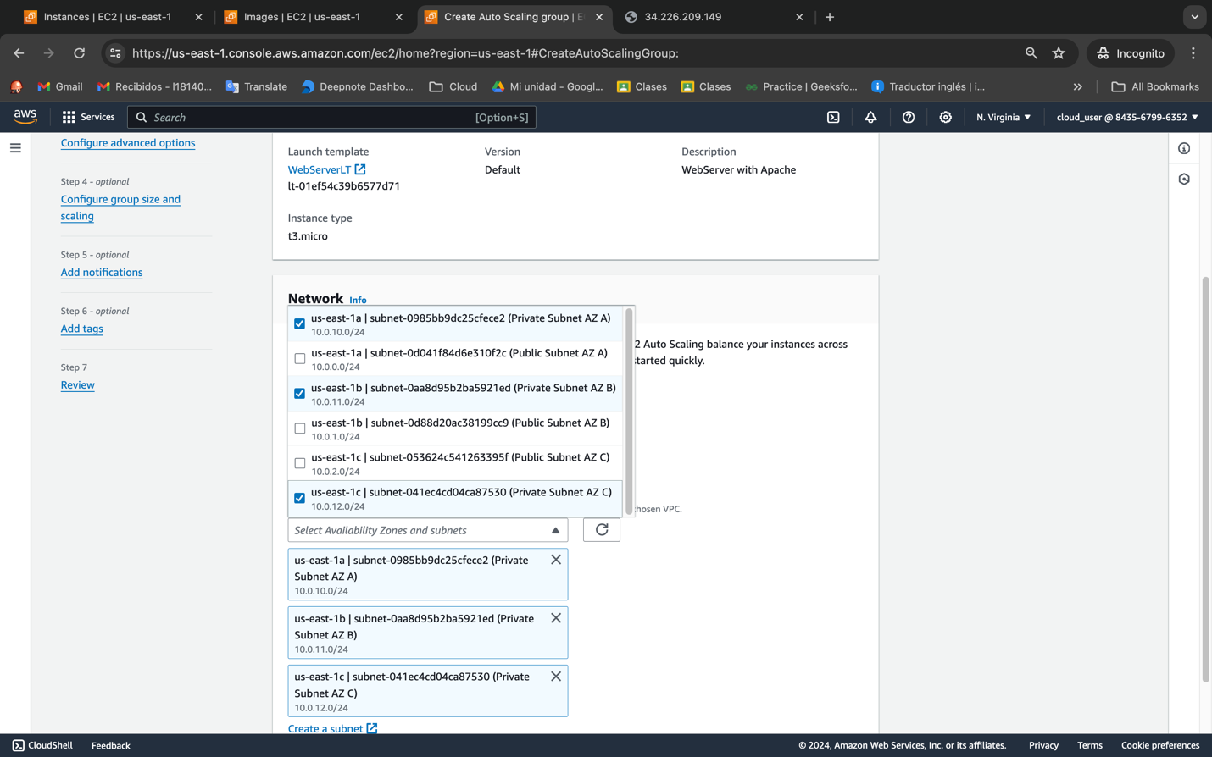

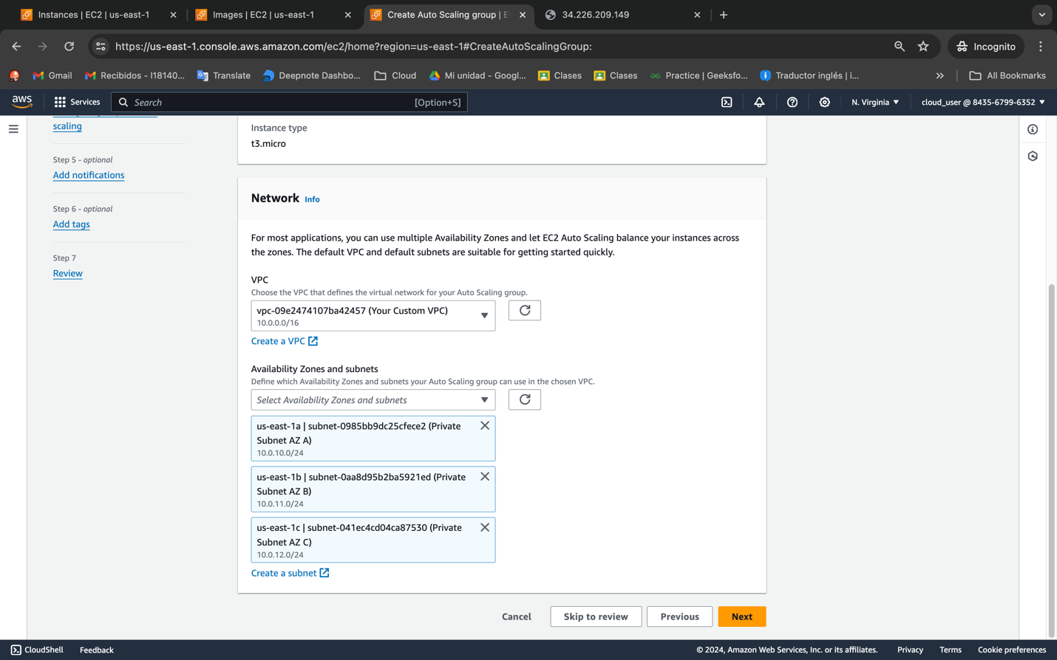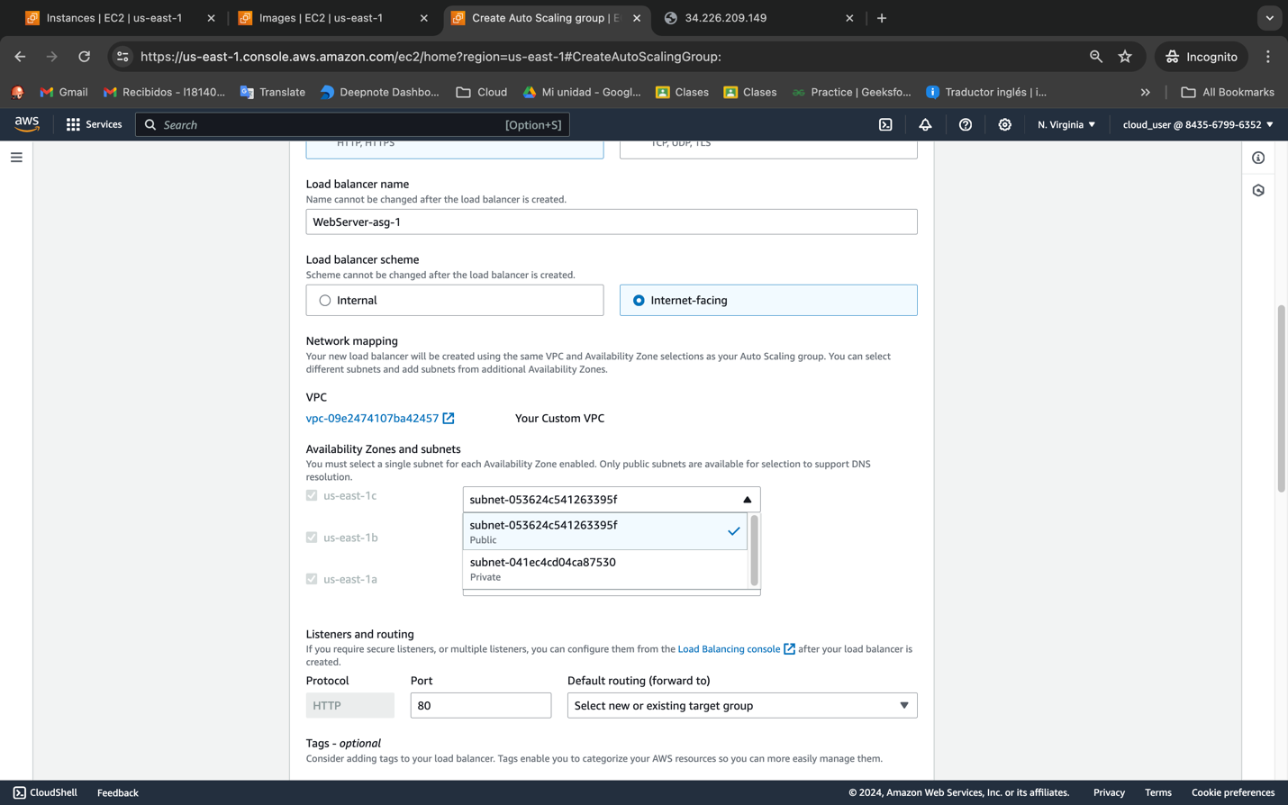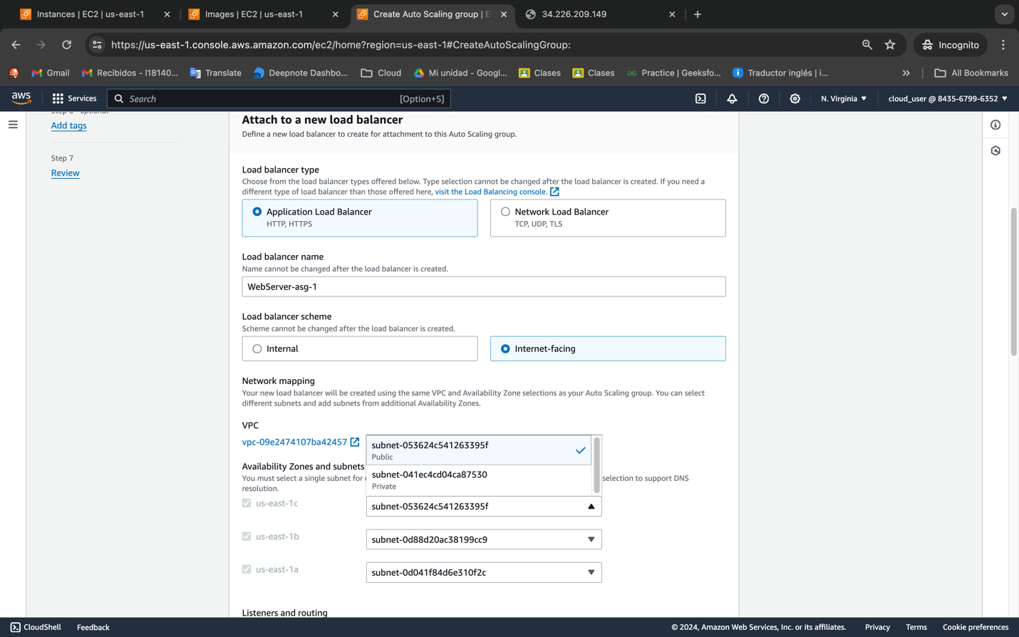

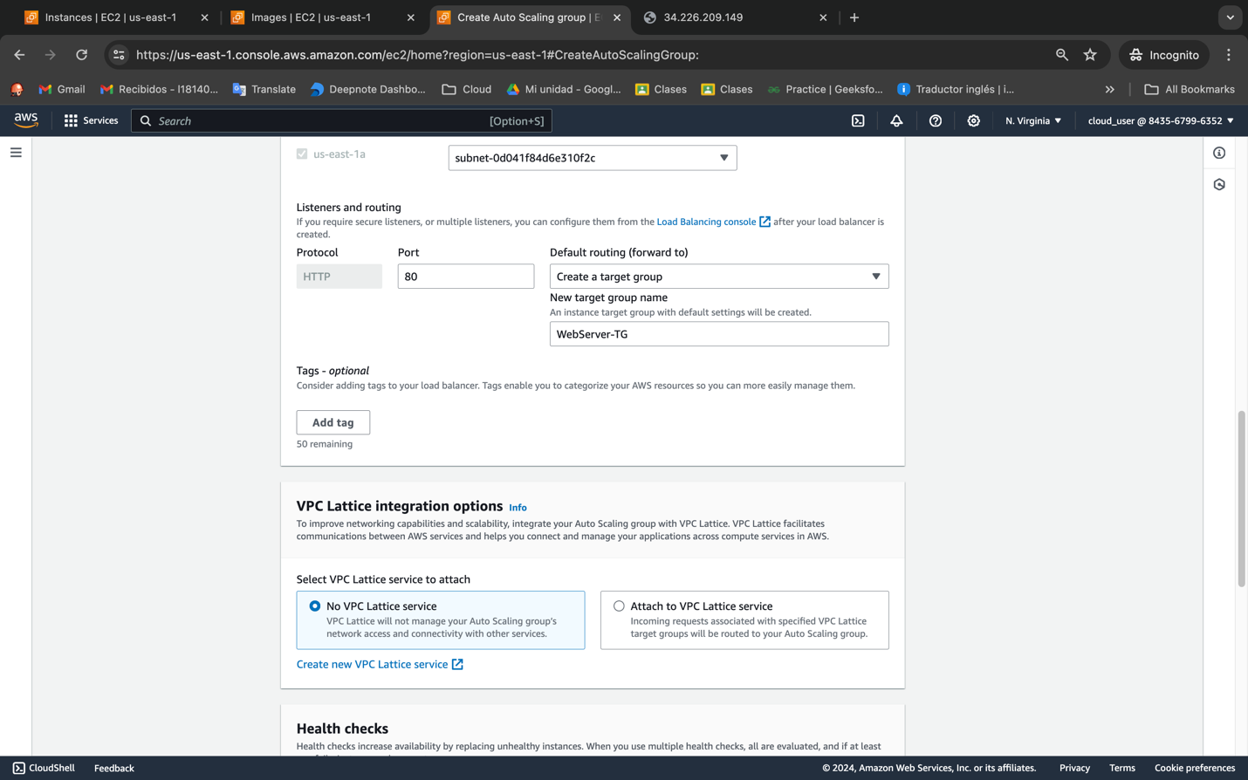

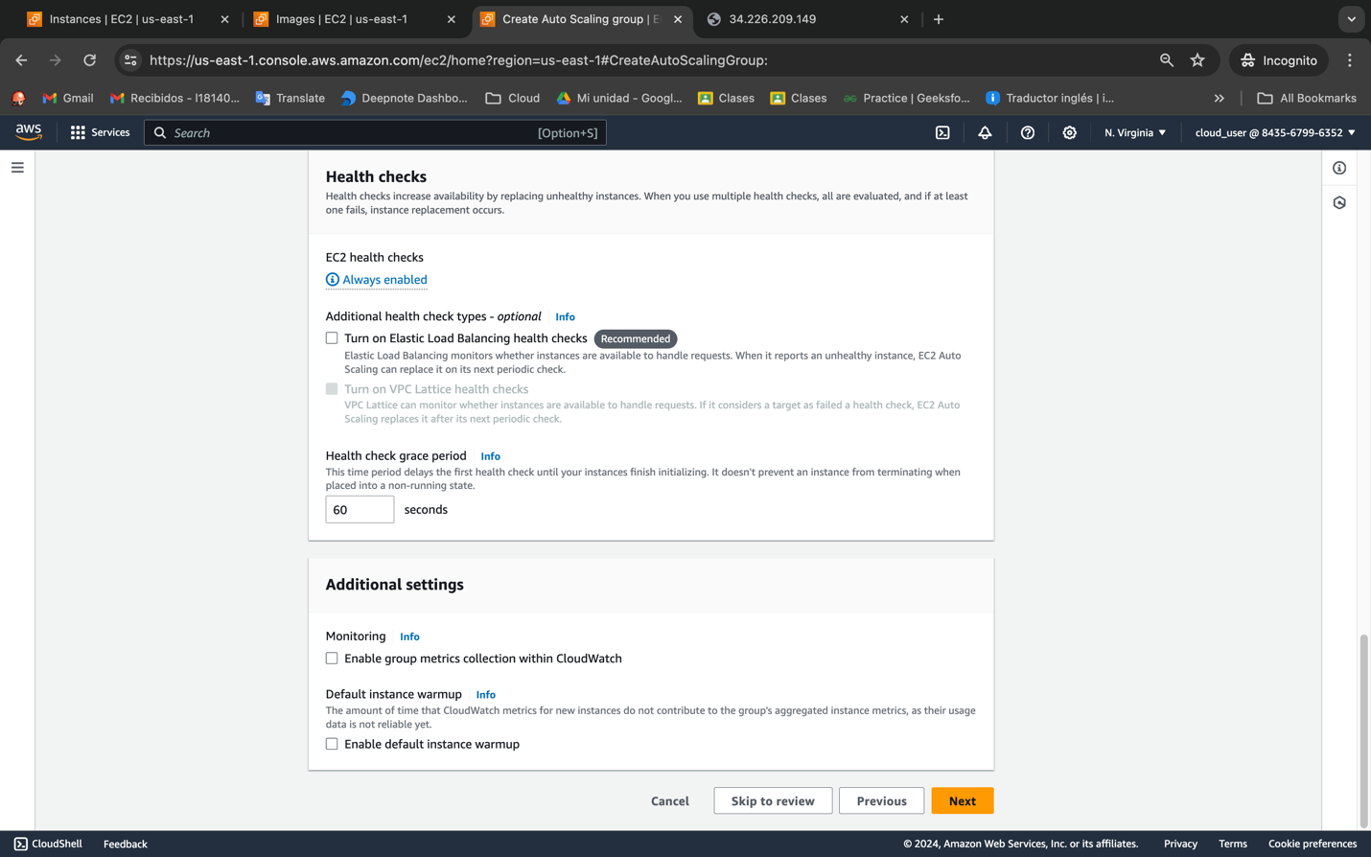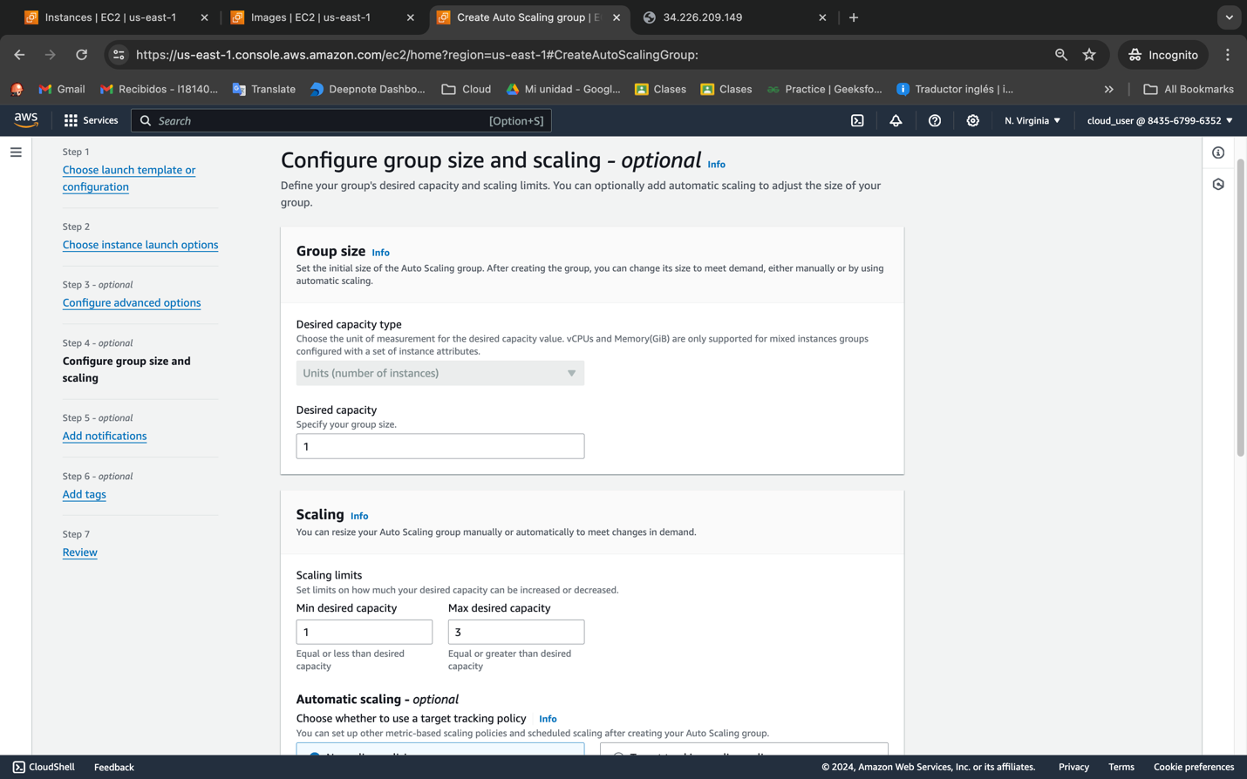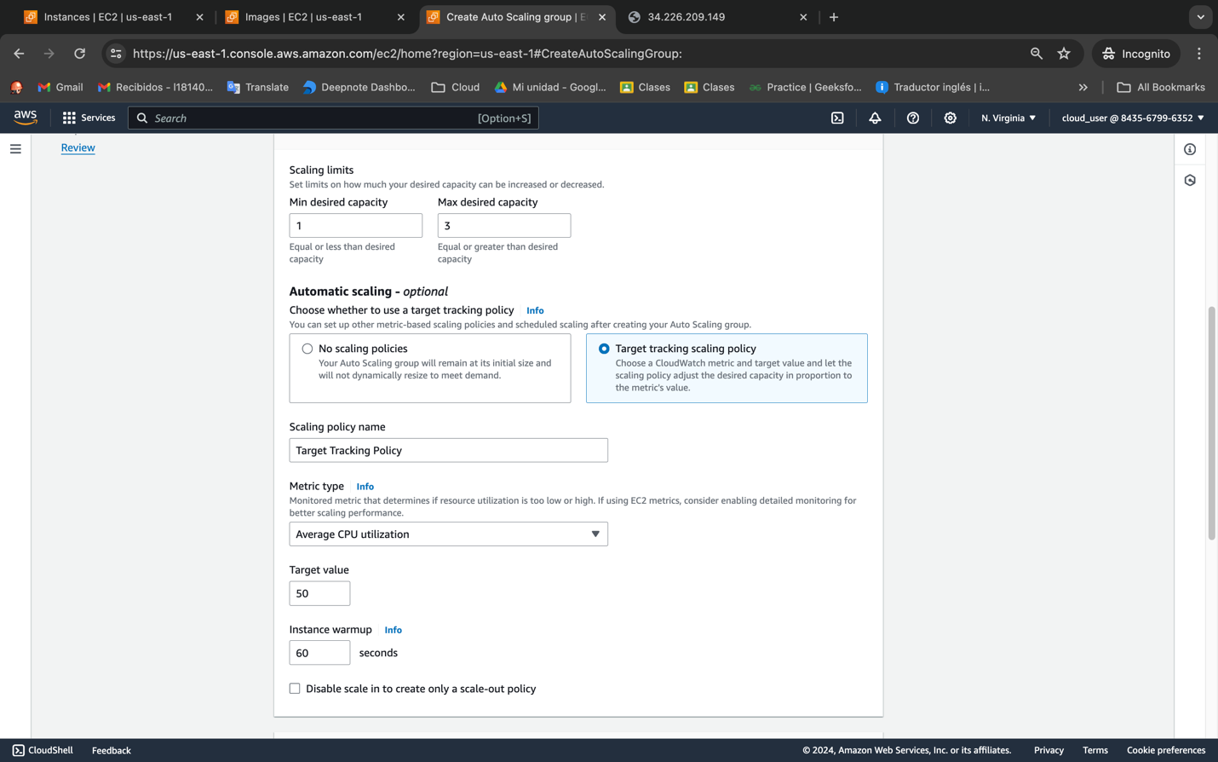

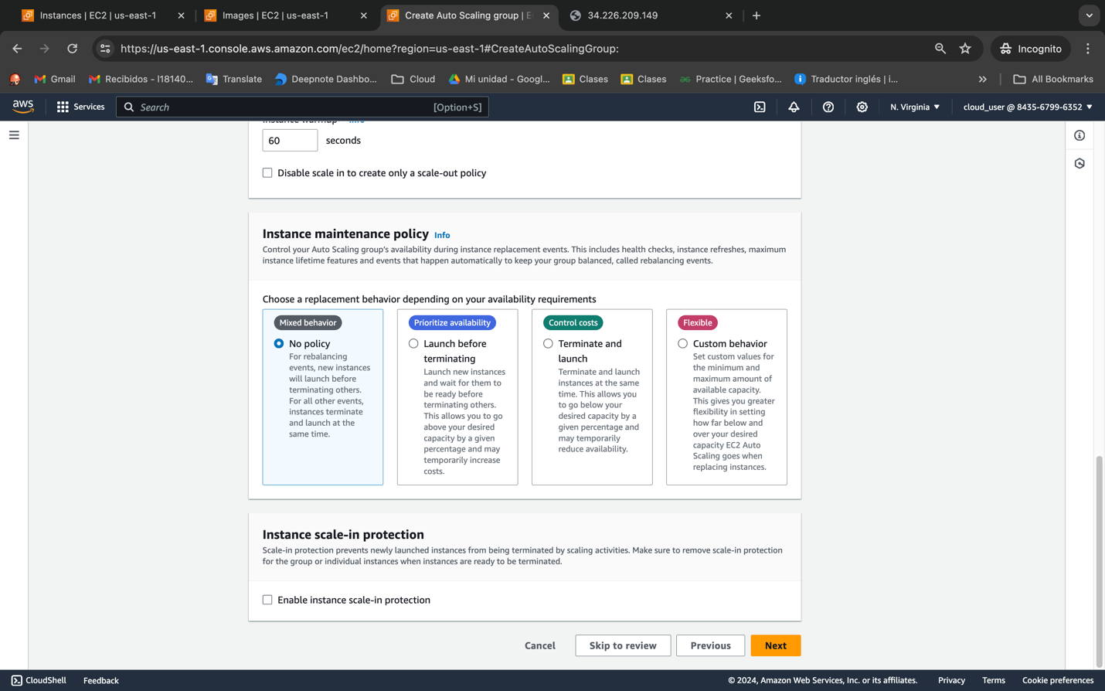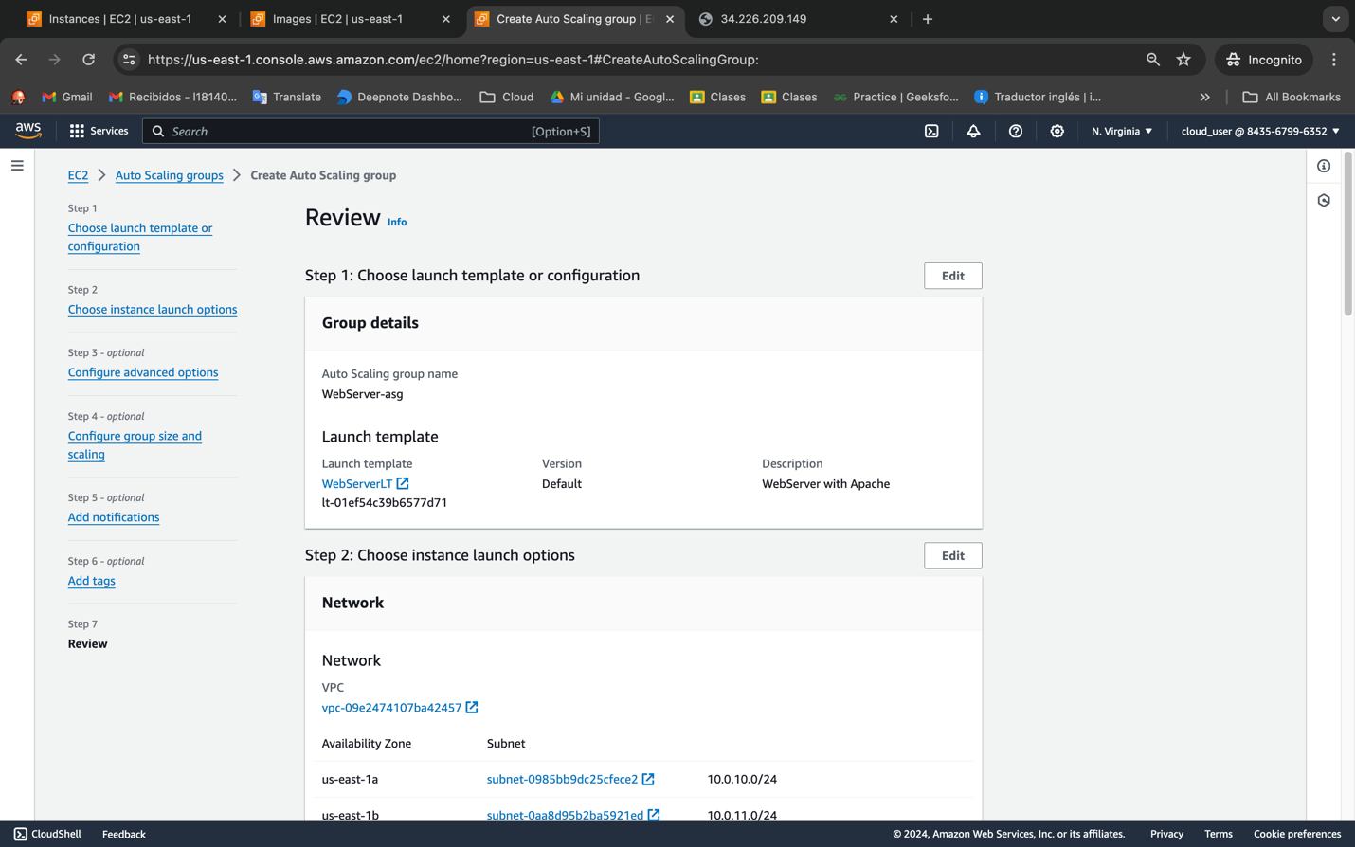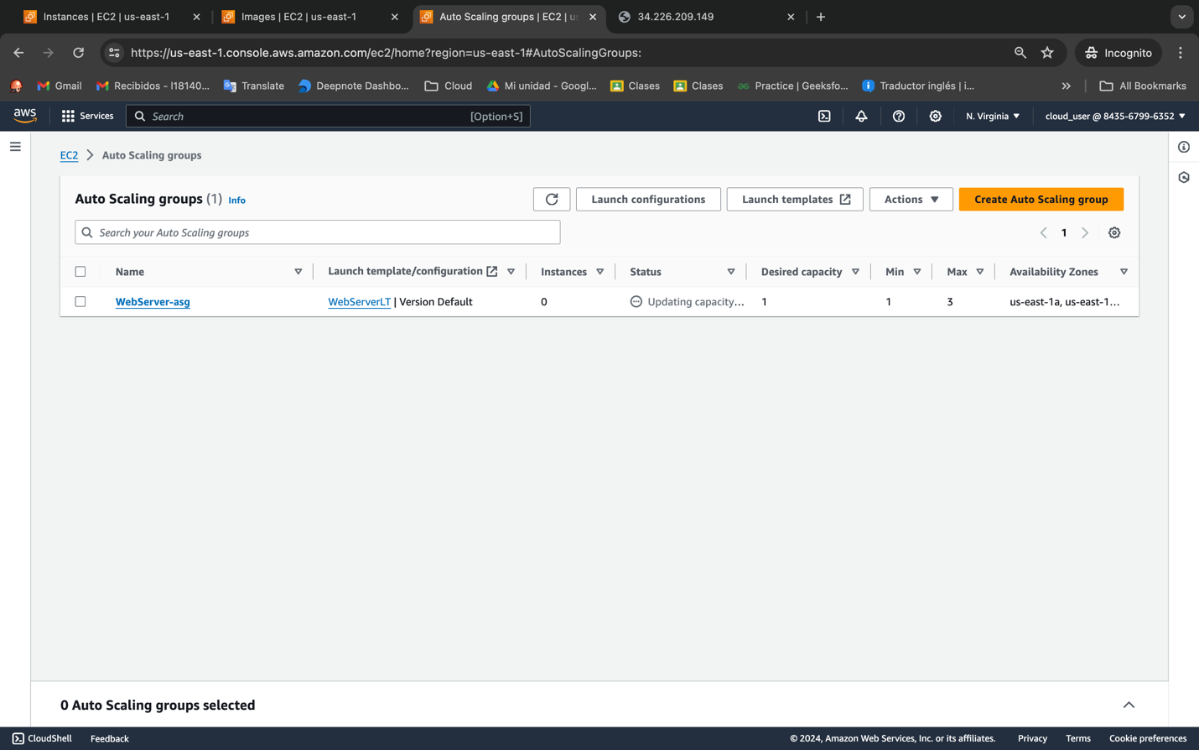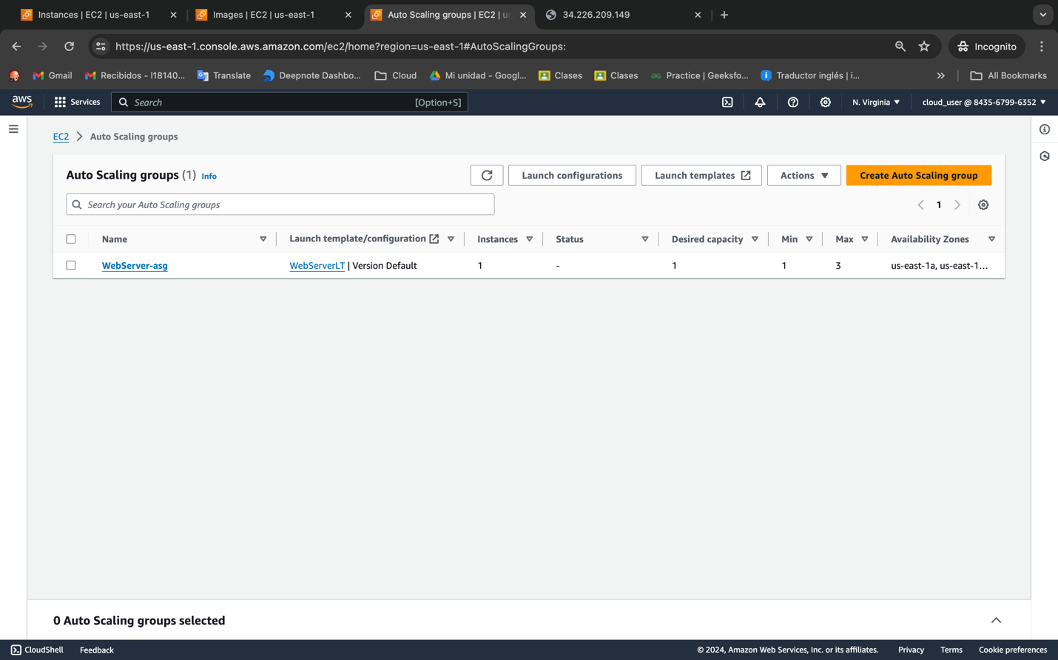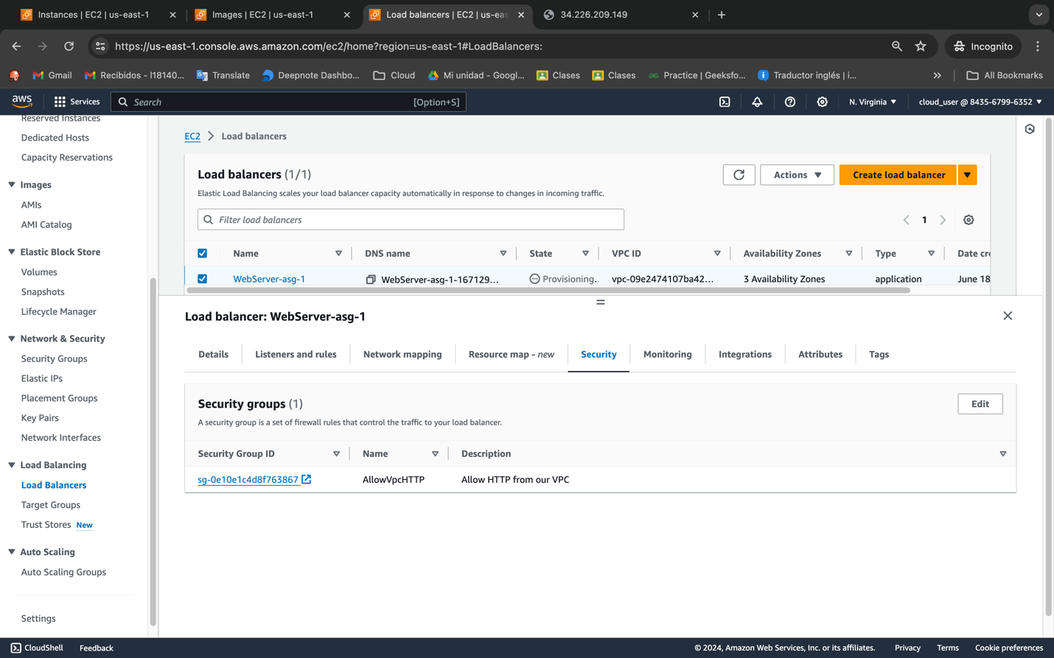

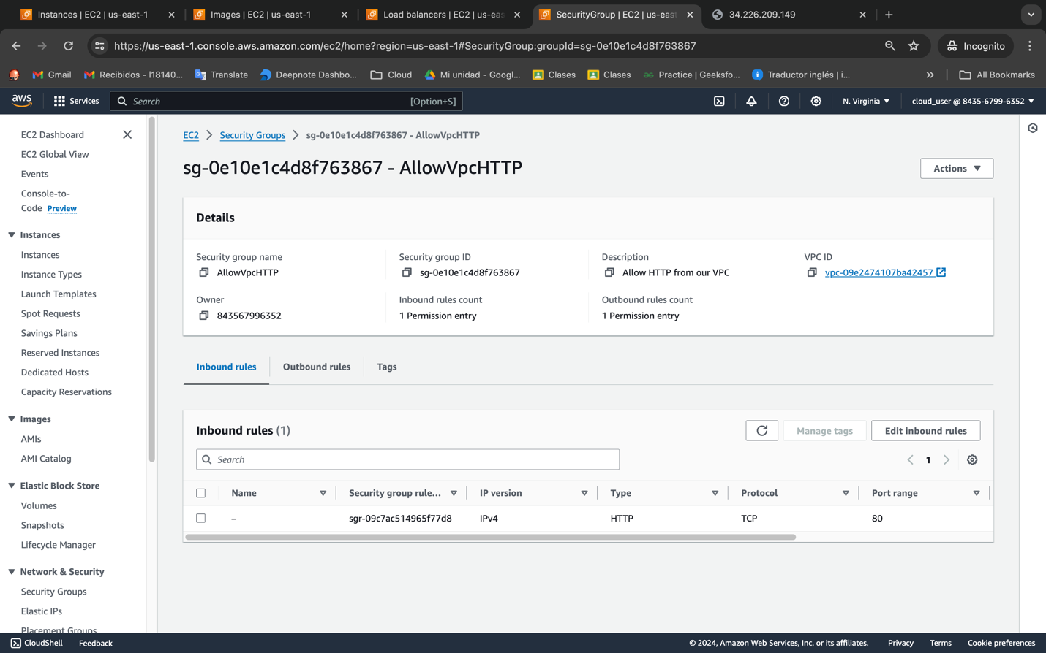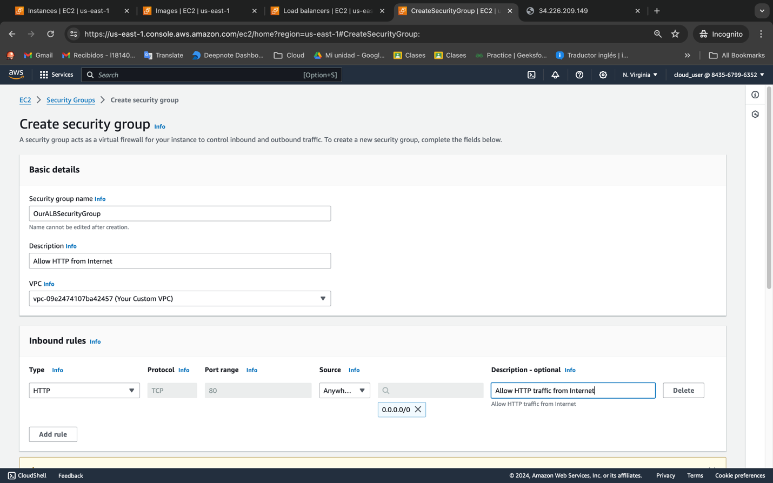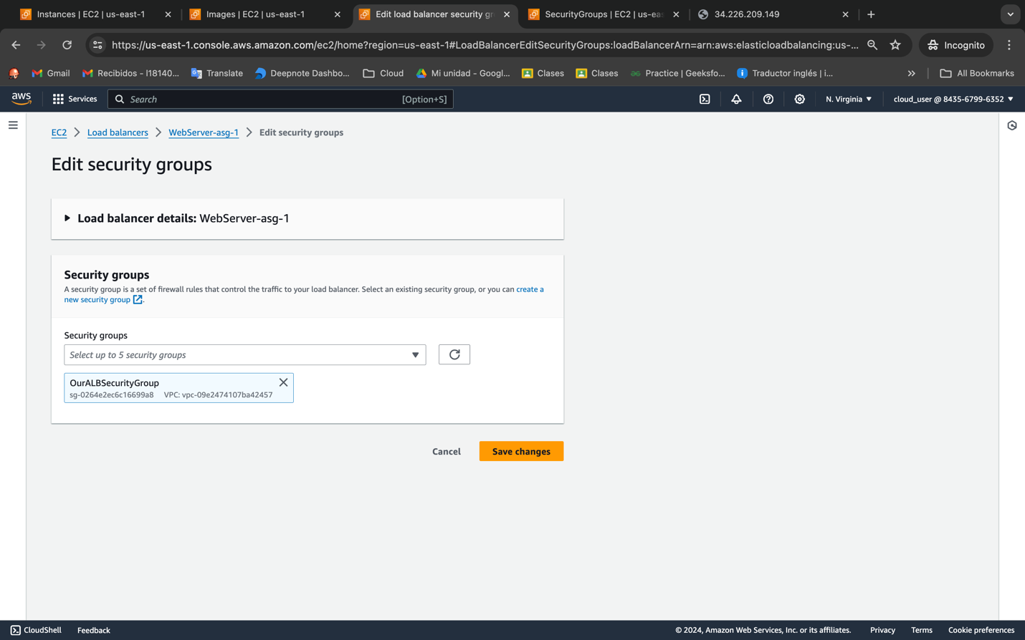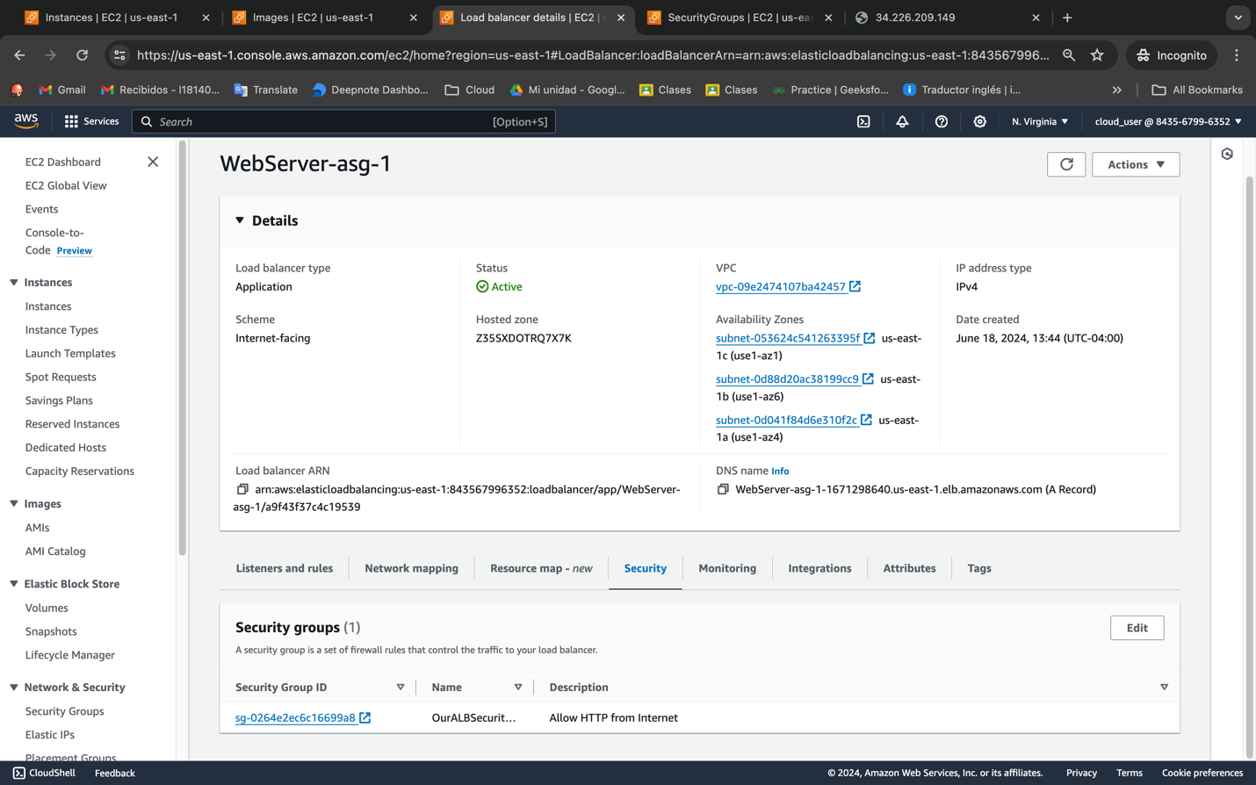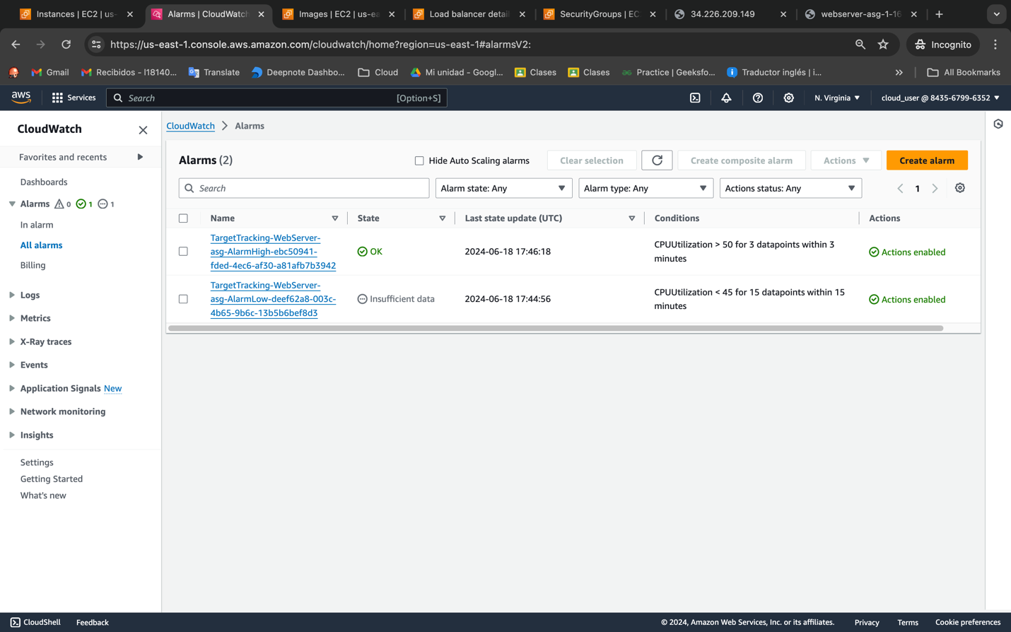

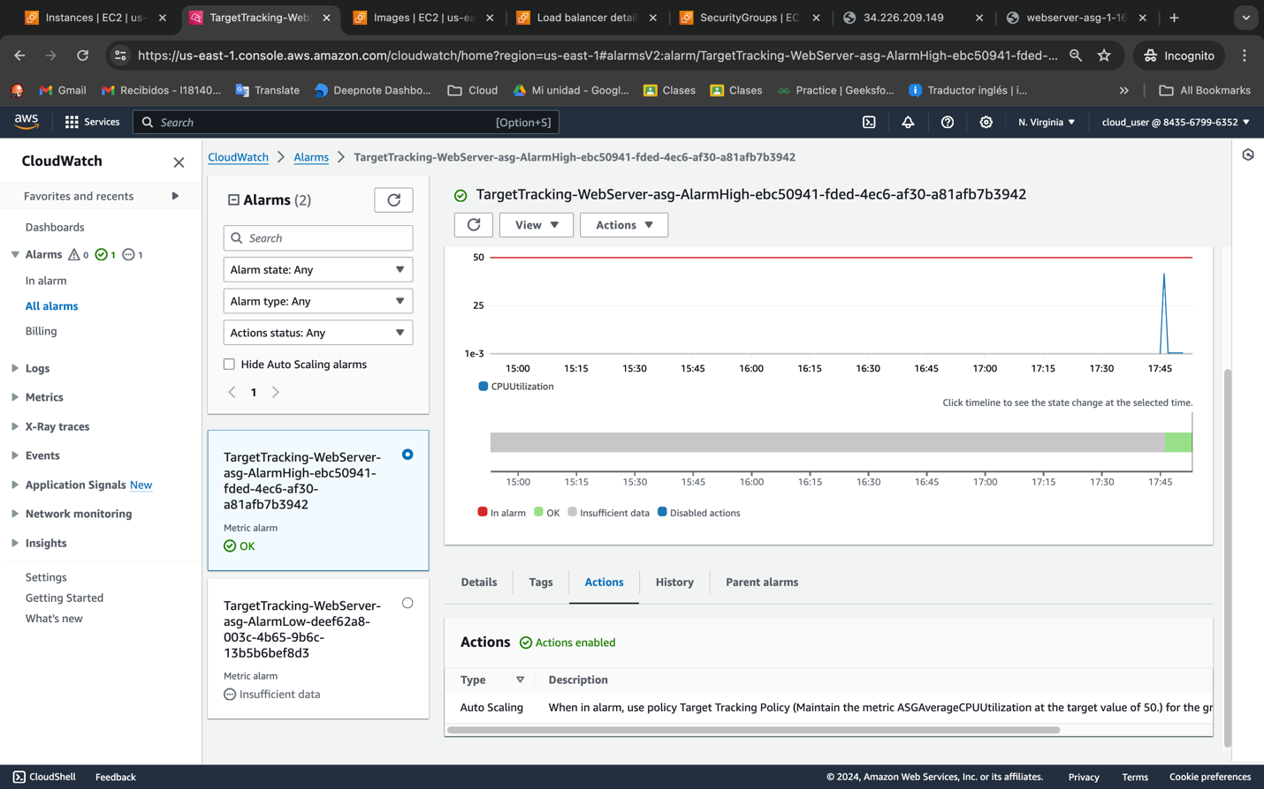

When in alarm, use policy Target Tracking Policy (Maintain the metric ASGAverageCPUUtilization at the target value of 50.) for the group WebServer-asg

